Write Your Own Feudal Oath!
Make-Up Assignment

Introduction
Your classmates were required to get into pairs and write a feudal oath. Together, they wrote both the Lord and the Vassal’s parts and copied their drafts into good copies on decorated paper. They then did a dramatic performance of their oaths in front of the class.

Because you were not present, you are not required to do the dramatic presentation part of the assignment. However, to even out the workload, you must do the written parts of the assignment individually rather than in pairs.

Thank you to those of you who informed me that you would not be in class ahead of time! In the future, please let me know if you are going to miss class so I can plan around your absence.

Instructions
- Create a Lord and a Vassal with Medieval names (Lady Manny of Kitsilano, King Howie of The Backstreet Boys, etc.)

- Write the Lord`s oath & decide on a fief (the fee or reward offered to the vassal). You can make your oaths historically accurate, or use modern places or things as long as you follow the basic principles of the Feudal Oath.

- Based on the fief, write the oath of the vassal. Decide what the vassal would have to give to the Lord in return to make an even exchange.

- Decide on consequences for both parties if one were to break the oath and include those on your drafts.

- Make a good copy and sign it with your parties’ names. It should be neat and decorated to look Medieval.

Example of Feudal Oath using Modern places/things, etc.:
I, Queen Margaret of Manitoba, grant you a fief in Vancouver including a carwash, McDonald`s, 3 miles of beach and a yacht.
I, Baroness Michelle of Downtown Vancouver, will provide to you, the Queen Margaret of Manitoba, a king-sized bed in my condo whenever you may choose to visit, espresso every morning, a butler and free dry cleaning of all of your robes.
If I, Baroness Michelle of Downtown Vancouver, or any of my successors do not observe to thee each and all of the promises here declared, then I shall grant you my collection of designer handbags, my Mercedes Benz, and my firstborn child to act as your personal assistant as long as you both shall live.
Queen Margaret of Manitoba Baronness Michelle of Downtown Vancouver
Write Your Own Feudal Oath!:
More Primary Source Examples

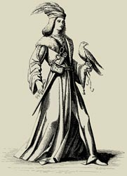
13th century France - Fealty Oath of John of Toul (a Lord)
I, John of Toul, make known that I am the liege man of the lady Beatrice, countess of Troyes, and of her son, Theobald, count of Champagne, against every creature, living or dead, saving my allegiance to lord Enjorand of Coucy, lord John of Arcis, and the count of Grandpré. If it should happen that the count of Grandpré should be at war with the countess and count of Champagne on his own quarrel, I will aid the count of Grandpré in my own person, and will send to the count and the countess of Champagne the knights whose service I owe to them for the fief which I hold of them.

But if the count of Grandpré shall make war on the countess and the count of Champagne on behalf of his friends and not in his own quarrel, I will aid in my own person the countess and count of Champagne, and will send one knight to the count of Grandpré for the service which I owe him for the fief which I hold of him, but I will not go myself into the territory of the count of Grandpré to make war on him.

Signed by the grace of God in the reign of Louis, John of Toul

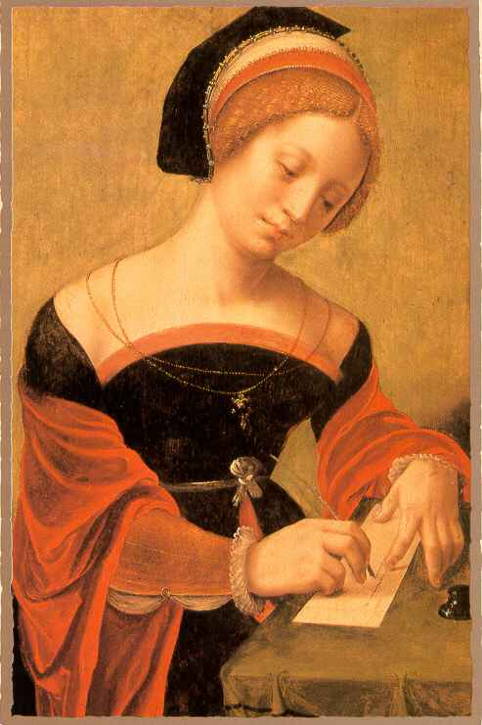
1201 Feudal Contract of Blanche of Navarre, Countess of Champagne
(after Theobald's death)

I, Blanche, Countess palatine of Troyes. Be it known to all, present and future, that I have voluntarily sworn to my lord, Philip, king of France, to keep the agreements contained in this charter.... I have voluntarily sworn that I will never take a husband without the advice, consent, and wish of my lord, Philip, king of France, and that I will place under his guardianship my daughter and any child of whom I may be pregnant from my late husband, count Theobald.

In addition, I will turn over to him the fortresses of Bray and Montereau, and give him control of all the men who dwell there and all the knights who hold fiefs of the castles, so that if I break my promise to keep these agreements, all the aforesaid men shall hold directly of my lord, Philip, king of France; They shall swear to aid him against men and against every other man or woman.

The lord of Marolles shall put himself and his castle also under the control of the king, and similarly all the knights who hold fiefs of Provins, and all the men of Provins, and all the men of Lagny and Meaux, and all the knights who hold fiefs of these places.... I will do liege homage to my lord, Philip, king of France, and I will keep faith with him against all creatures, living or dead.

Enacted in Troyes, in the year of grace 1201, in the month of August
Blanche of Navarre, Countess of Champagne

